Styles, Style Sheets, the Box Model and Liquid Layout
This session will guide you through examples of how styles and Cascading Style Sheets (CSS) may be used in your Web pages to simplify maintenance of your pages / site. We shall also take a look at how the box model may be used to control the positioning of content on a page.

Introduction to Styles
To begin with take a look at the following two documents...
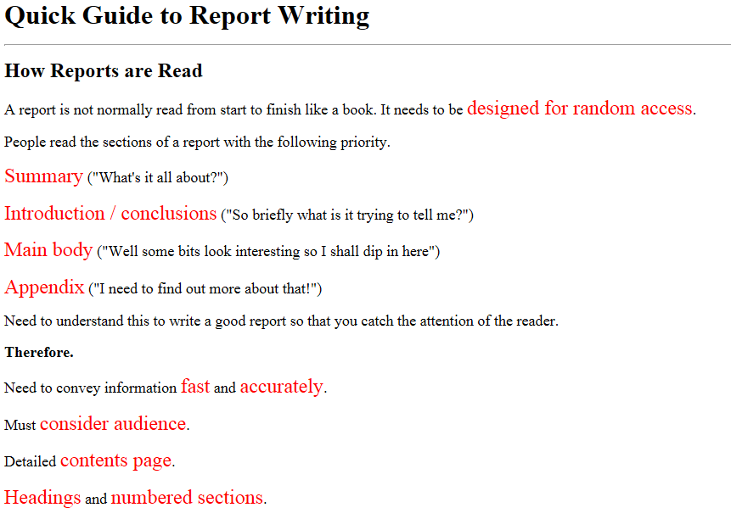 | 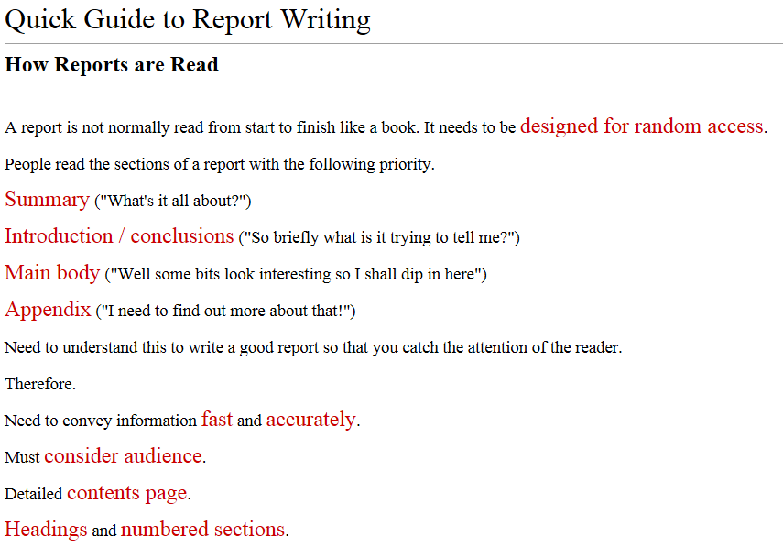
Bad | Better
So what is the difference between the two documents?
The contents of both documents are pretty much identical. However there are significant differences in the way that the documents are organised internally.

Overview of HTML
A simple HTML document has the following format...
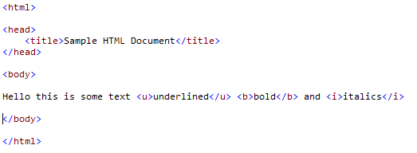

The Font Tag
If I wanted to make a section of text a different colour one way we could do this is to use the font tag...
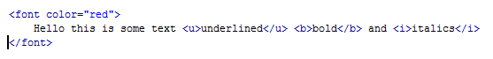
Before proceeding to the next section, look at the documents again but this time view the source HTML they are based on.

The Bad Example – Embedded Styling
The bad example has been created without the use of styles and is fairly typical of how many amateur web pages are created...
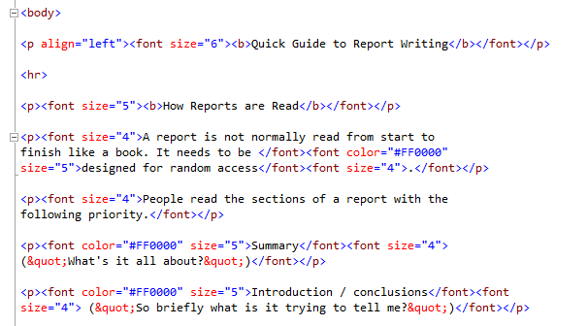
For example when the text is “styled” we are using the “deprecated” or outdated HTML tag called <font>
This means that the HTML for the red text...
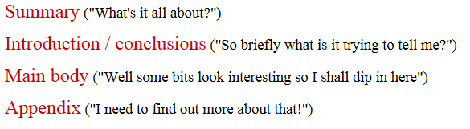
Is constructed like so...
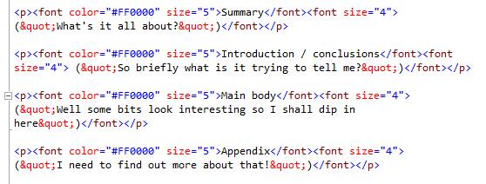
What we are doing here is formatting each instance of the red text with its own <font> tag.
In this document there are 63 instances of red text applied throughout the document.
The problem comes when we want to change the text of the red sections to blue or some other colour. To do that we will need to make 63 changes to the entire document.

The Better Example – Internal Style Sheet
For this document we have modified the internal structure of the document and created an internal style sheet.
If you view the HTML for your page you will see the internal style sheet:
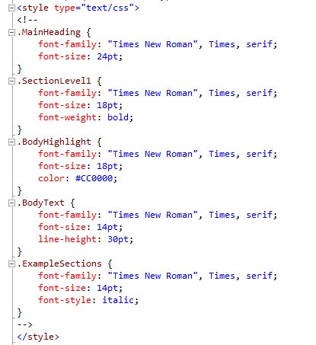
This style sheet defines the five styles that we are using within the document.
So the code defines a style Class called .BodyHighlight.
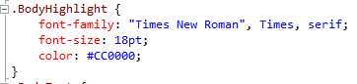
A style is defined once in the style sheet, then, when we want to use it we mark up the HTML using suitable tags.

Marking up the HTML
Once a style is defined in a style sheet then there needs to be some mechanism for applying the style to the HTML. This process is called styling your pages.

In general there are two sorts of styles that may be applied, they are inline and block.

Inline styles when applied to the text do not add a new paragraph to the marked up section.

For example the text

Uses the <span> tag to apply the style like so...

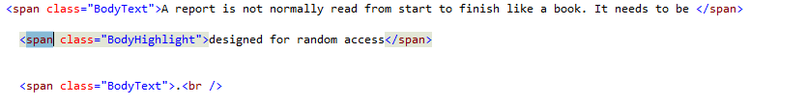

Div versus Span
Applying a span keeps the flow of the text. For example when viewed in the browser the formatted text would look something like this.
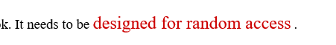

Block styles when applied create a new paragraph and would not be suitable for use in this section of text.

If the second line of mark-up is changed from a <span> to a <div> like so...

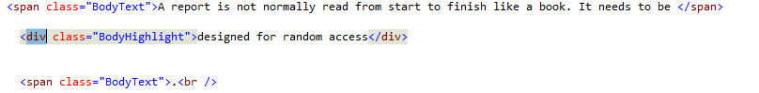

We are now applying block level formatting. Resulting in the text looking like this...

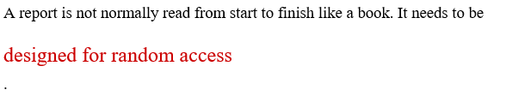

Not quite the effect we are after.

Inline formatting <span> is normally used if we want to format words within a sentence. Block <div> formatting is used if we want to format an entire block of our page for example an entire paragraph.

The Best Example - External Style Sheets
The third example we have already mentioned in storing our styles is to make use of an external style sheet.

In the example above we have created a set of styles which may be used in this document only.

The external CSS is a separate file to the HTML. The CSS file contains all of the styles and the HTML contains the unformatted content along with a line of HTML telling the page where to get its formatting.

The external style sheet is a separate file to the HTML document. In the case of an internal style sheet it only applies to a single page. A single external style sheet may be applied to multiple pages.

The big advantage of an external style sheet is that a single change here impacts the look of the whole site. Internal style sheets are useful if you want to apply changes to individual pages only.

Layout using Styles and the Box Model
As well as allowing us to format specific sections of text using <span> and <div> we also have the option of laying out the positioning of text and graphics using styles.

HTML 5
HTML 5 gives us a set of new tags which are helpful in deciding on the names we may use to format the document.

For example...

header
footer
nav
article
section
section
aside

Notice that the names of the sections describe what they do not where they go.

header Content that appears on every page of the site typically at the top
footer Content that appears on every page of the site typically at the bottom
nav The navigation elements for the page
article The main document for this page
section A sub section in the main document
aside A section on the page with additional information (often advertising)

Creating the Layout

We shall set up a new HTML document with the following unformatted content...

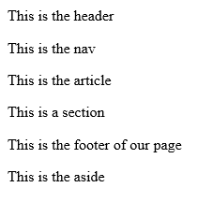
Here is the HTML for the page.

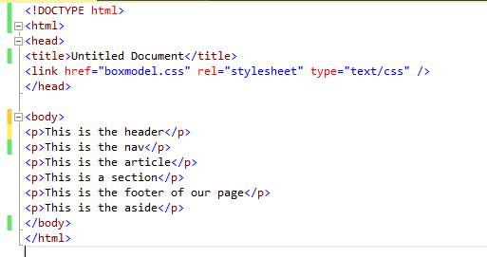

The next step is to create an external style sheet to store the styles...

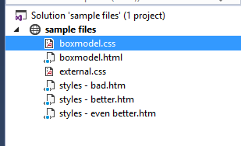

We are not going to format every style in this example we shall concentrate on the header style for these examples.

The first thing to notice is the flow of the text...

In formatting a specific section of text we have several options to consider in its positioning.

- Static - We may leave the text in the flow of the text
- Absolute - We may remove the text from the flow and specify exact coordinates with respect to the parent container
- Fixed - We may remove the text from the flow and specify exact coordinates with respect to the browser window
- Relative - We may position the text relative to its position in the flow

Re-Defining Tags
One thing that we can do in applying styling to HTML is to re-define existing tags.

What this means is that we can apply formatting to the page whenever a tag appears.

This means the first thing we need to do is mark-up the document o state where the formatting we want will apply, like so…

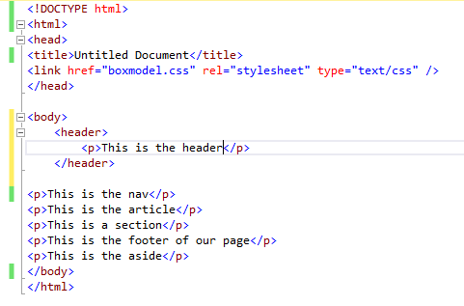

In order to understand the box model we need to think of the text as having a box drawn round it...

Margin
Border
Padding
This is the header
Text or graphics to format
White space between the border
Outside border of content
White space outside of the border
Top
Left
Width
Height

As well as the boxes within the main box the main box also has a top, left, height and width property.

These are often determined with reference to the parent container which may or may not be the main browser window!

The first thing we will apply is a border so that we can see where the edges of the styling are applied.

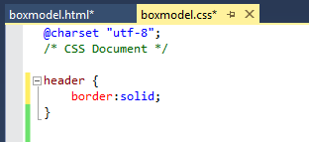

Which creates the following effect…

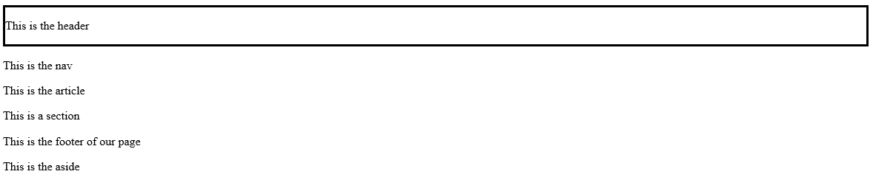

Adjusting the Padding
If we change the padding we may change how the text sits in relation to the border...

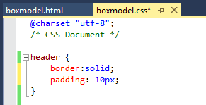

Resulting in 10 pixels (px) of space between the text and the border…

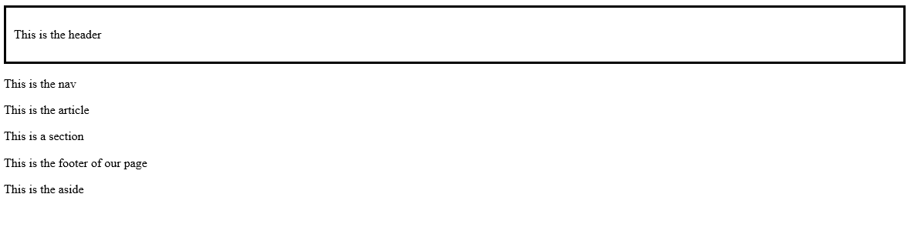

Adjusting the Margin

If we increase the margin we increase the spacing beyond the border...

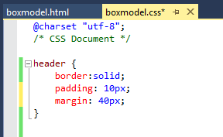

Like so...

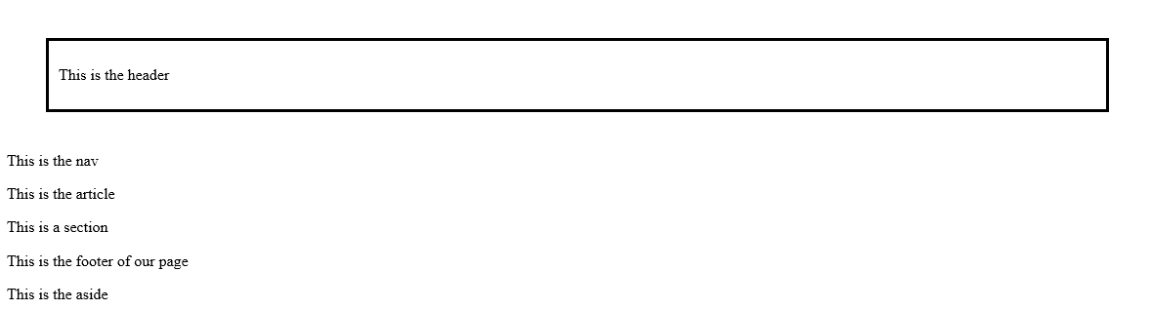

Changing Positioning

We may also change the way that the style is positioned and take it out of the flow of the text by changing the position to absolute...

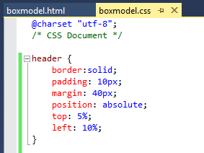

Producing the not very attractive...

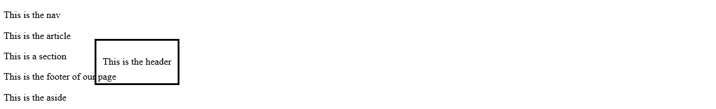

Notice so far we have been setting the units of measurement as “px” pixels or dots.

It is also worth considering if % or em produce better results.

- A percentage value mans that the box is calculated as a percentage of its parent.

- An em value means that the box size is calculated based on the size of the specified font.

Percentage values work well in many cases however an em value will scale better if large fonts are used.

In this next example if we set the top and left of the box to 5% the box will scale even if we change the size of the browser window (or view the same page on a mobile phone!)

Adjusting Width and Height
The following changes…

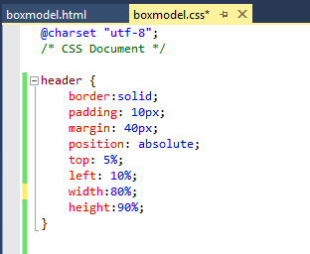

Give us…

